Cp-10 |  | SMA cp-10 fault troubleshooting  - 0104
Notes: First response is always to verify current grid conditions.

- Visual References:
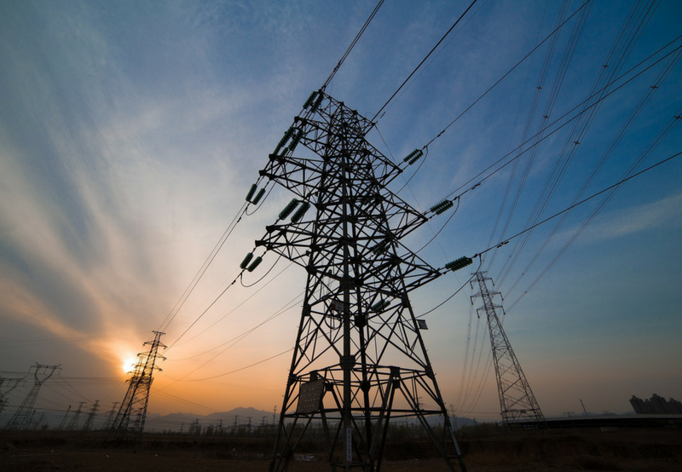

Figure 1

Fault Descriptions and Likely Causes:
SMA: Grid over voltage fast.

This indicates voltage exceeded inverter lower limits.

- Nearby grid equipment operating
- Storms or lightning
- Possibly associated with a subsequent inverter failure

- Troubleshooting

- Reference material

- Text

[Insert picture]
Figure 2 – text

[insert picture]
Figure 3 – text

[insert picture]
Figure 4 – text

- Text

- Part information

